LIBRARY INFORMATION MANAGEMENT SYSTEM

A CASE OF MOROGORO REGIONAL LIBRARY

LIBRARY INFORMATION MANAGEMENT SYSTEM

A CASE OF MOROGORO REGIONAL LIBRARY

By

Elia J. Mbeppo

A Project Report Submitted to Department of Computing Science Studies (CSS) of Faculty of Science and Technology (FST) in Partial Fulfilment of the Requirements  
for Award of the Degree of Bachelor of Science in Information and Communication  
Technology with Management (B.Sc. ICT-M) of Mzumbe University

June 2018

# CERTIFICATION

We, the undersigned, certify that we have read and hereby recommend for acceptance by the Mzumbe University, a project entitled **Library Information Management System: The Case of Morogoro Regional Library,** in partial fulfillment of the requirements for award of the degree of Bachelor of Science in ICT with Management (B.Sc. ICT-M) of Mzumbe University

Signature

______________

Mr. Frank G. Kilima

Major Supervisor

Signature

______________

Internal Examiner

# DECLARATION AND COPYRIGHT

I, Elia J. Mbeppo, declare that the project entitled “**LIBRARY INFORMATION MANAGEMENT SYSTEM: A CASE OF MOROGORO REGIONAL LIBRARY.**”is my own original work and that it has not been presented and will not be presented to any other university for a similar or any other degree award.

Signature: _________________

Date: _____________________

Copyright © 2018 by Elia J. Mbeppo. All rights reserved. This project report or any portion thereof may not be reproduced or used in any manner whatsoever without the express written permission of the project owner or Mzumbe University.

# ACKNOWLEDGEMENT

Thanks to God almighty for his blessings and grace that I were to complete this project successfully.

I extend my gratitude to my supervisor Mr. Frank G. Kilima for his esteemed guide and support throughout the project.

My sincere gratitude to my family, friends, and colleagues who have provided me with love, support and humility, throughout the entire project.

# ABBREVIATIONS AND ACRONYMS

|  |  |
| --- | --- |
| LAN | Local Area Network |
| CSS | Cascading StyleSheets |
| DSDM | Dynamic Systems Development Model |
| GHz | Gigahertz |
| GUI | Graphical User Interface |
| HTML | HyperText Markup Language |
| ILS | Integrated Library Systems |
| JAD | Joint Application Development |
| JDK | Java Development Kit |
| LIMS | Library Information Management System |
| PHP | HyperText Preprocessor |
| RAD | Rapid Application Development |
| RAM | Random Access Memory |
| RUP | Rational Unified Process |

# ABSTRACT

A library information management system is a project work aimed at developing a system that would automate and simplify activities done by Morogoro Regional Library.

The system is made up of two parts which are web application and desktop application. The web part is implemented by HTML and CSS as fronted technologies, PHP as a backend technology and MySQL for database implementation. The desktop part has employed Java SE and JavaFX framework.

The system has many features some of which are not available in the existing system. Some of these features include login process which ensures that only authorized users can access required information, automatic report generation where reports from library departments are generated automatically, auditing where each user’s action is logged in to the system’s database so as to know when each other accessed the system and what actions did they perform, an online book catalogue where customers can search books by title and category to see if they are available in the library and an online registration form where customers can register for a library membership. The system also has access control feature where information’s access is limited to specific departments. Here each user can access only information related to his/her department and only the administrator has access to all information.

Table of Contents

CERTIFICATION ii

DECLARATION AND COPYRIGHT iii

ACKNOWLEDGEMENT iv

ABBREVIATIONS AND ACRONYMS v

ABSTRACT vi

CHAPTER ONE: INTRODUCTION AND PROBLEM DESCRIPTION 1

1.1 Background of the problem 1

1.2 Problem statement 1

1.3 Project objectives 1

1.3.1 Main objective 1

1.3.2 Specific objectives 1

1.4 Significance of the system 2

1.5 Scope of the system 3

CHAPTER TWO: LITERATURE REVIEW 4

3.1 Introduction 4

CHAPTER THREE: REQUIREMENT ELICITATION AND SYSTEM ANALYSIS 10

3.1 Introduction to requirement elicitation 10

3.2 Requirement elicitation methods 10

3.3 Identification of stakeholders 11

3.4 Functional UML diagrams 12

3.5 System requirements 14

3.5.1 Functional requirements 14

3.5.2 Non-functional requirements 14

CHAPTER FOUR: SYSTEM DESIGN 16

4.1 Introduction to system design 16

4.2 System development methodology 16

4.3 Database design 18

4.4 User interface design 19

CHAPTER FIVE: SYSTEM IMPLEMENTATION 21

5.1 Introduction 21

5.2 Functionalities implementation 21

5.3 User Interface Implementation 23

5.4 Database Implementation 25

5.5. System testing and evaluation 28

CHAPTER SIX: CONCLUSION AND RECOMMENDATION 30

6.1 Summary of achieved objectives 30

6.2 Conclusion 30

6.3 Recommendations and future works 31

REFERENCE 32

Figure 1: Library Information Management System - Web application use case 13

Figure 2: Library information management system - Desktop application use case 13

Figure 3 : Incremental Development Methodology 17

Figure 4 : Entity Relationship Diagram between Book, Publisher, Category and Author 18

Figure 5 : Entity relationship diagram between librarian, book, lending and returning 19

Figure 6 : Entity relationship diagram between member, primary student, secondary student and adult 19

Figure 7: A sketch of a login window (Source: Project Report 2018) 20

Figure 8: A sketch of main window (Source: Project Report 2018) 20

Figure 9: Website home page (Source: Project Report 2018) 21

Figure 10: Results of book searching page (Source: Project Report 2018) 22

Figure 11: Membership registration form (Source: Project Report 2018) 22

Figure 12: Book table (Source: Project Report 2018) 23

Figure 13: Publisher table (Source: Project Report 2018) 23

Figure 14: Category table (Source: Project Report 2018) 23

Figure 15: Author table (Source: Project Report 2018) 24

Figure 16: Book_Author table (Source: Project Report 2018) 24

Figure 17: Librarian table (Source: Project Report 2018) 24

Figure 18: Member table (Source: Project Report 2018) 24

Figure 19: Member_Primary table(Source: Project Report 2018) 24

Figure 20: Member_Secondary Table (Source: Project Report 2018) 26

Figure 21: Member_Adult table (Source: Project Report 2018) 26

Figure 22: Lending table (Source: Project Report 2018) 26

Figure 23: Returning table (Source: Project Report 2018) 27

# CHAPTER ONE: INTRODUCTION AND PROBLEM DESCRIPTION

## 1.1 Background of the problem

A library is a building or room containing collections of books, periodicals, and sometimes films and recorded music for use or borrowing by the public or the members of an institution. (Google, 2018) The aim of the library is to collect documents of various kinds, books, articles, maps, etc., and to identify the collection so that an individual who wishes an item from it can retrieve it successfully.

Morogoro regional library is located in Morogoro region in Tanzania. It is one among libraries under Tanzania Library Services Board (TLSB). It is the only public library in Morogoro region.

Morogoro regional library stores books and newspapers which are available to registered library members for reading. The publications can also be borrowed by the registered members for a period of two weeks.

Currently, membership registration process is done manually and requires people to arrive at the library with their identification information so as they can be registered. All recordings are done on counter books.

Morogoro regional library has five (5) departments or sections and each department has its functions. The departments are; registration, lending, technical, administration and management department. Registration department concerns with registration of library members and membership renewal as well as keeping track of registration timeline. The lending department concerns with issuing of books and returning of books as well as tracking late returns for payment of fines and penalties. The technical department concerns with keeping records of all publications that are kept in the library as well as book labeling, shelf labeling and maintaining a catalogue to enable library members to easily locate specific books in the library. Management concerns with reviewing of reports from all other departments, making important managerial decisions from the reports such as increase number of copies for certain books, some books are old and should be disposed off and also they can share these reports to the upper management. And lastly is the administration section that maintains all employees’ records.

## 1.2 Problem statement

Currently all the library information such as library staff records, library member’s records, records of issuing and returning books is managed manually and is stored in books. This manual way of recording of information is a tedious and time consuming task. The system makes searching for specific library records difficult due to the limitations of the way records are stored in a book, a librarian has to pass through each page of a book one by one to locate specific information. The system also relies on the librarians to be correct all the time, but humans are not perfect they can make mistakes and there is no way to for the system to validate and eliminate errors. Also making changes to stored information requires starting over instead of simply updating the specific part required. Library members are required to be physically at the library to ask if certain book exists in the library records. Generally the current system is not efficient and results to low quality of customer service of the library to its members.

## 1.3 Project objectives

### 1.3.1 Main objective

To develop an online (web-based) application and a desktop-based application that would automate morogoro library membership registration process, and manage library records as well as generating management reports.

### 1.3.2 Specific objectives

1. To review the existing library management systems.
2. To review and design system requirements
3. To design a web-based and desktop-based application that would automate membership registration process, manage library information such as staff records, publication records and members’ records as well generate management reports concerning the kept records.

## 1.4 Significance of the system

The project is primarily aimed to improve customer service at Morogoro regional library by reducing time spent on some tasks such as member registration process since members can register themselves online. Also members do not need to be at the library to request if certain book copies exist in the library.

The system is also aimed to reduce operational cost in the long run. Since all records are now recorded and kept in the computer system: manual files, books, and papers will be unnecessary.

The system provide a means of managing and storing consistent data and efficiently. Duplicate data will be eliminated automatically by the system. Human errors are disallowed during recording of information.

The system ensures data security as well as access control. Specific users of the system will be required to login with the credentials (username and password) to access the system. Unauthorized users will be denied access. The authorized users are further categorized according to their department and will each be able to access information regarding their department only.

Only the system administrator can add users and assign them to departments, and only the administrator has access to all the system data. The will protect all the library records against unauthorized change/modification, deletion or insertion.

The system can generate reports on different library information required by the management. The reports are on all publications recorded, categories, publishers, and library members, library staffs as well as issuing and returning of books. The reports can also be filtered on by dates, names, and departments. Automation of report generation is efficient and effective as no human errors are eliminated.

## 1.5 Scope of the system

**Targeted users**

All the librarians (library staff) according to their existing departments will use the system to records, and retrieve library information. Registration department will utilize the system to register and deregister members. Lending department will record issuing and returning of books as well as book tracking. Technical department will record and update all the publications existing in the library. The management department can view and print reports. And lastly the administration department will add and manage staff.

All library members and non members can use the online part of the system to request for books if they exist in the library records. Also non members can register themselves to become library members.

**Running environment**

The system requires at least 512MB of RAM, 2.0GHz of processing speed, and any operating system with JDK installed. The system also requires a LAN between client and server for the desktop part, and internet connection for the web application part.

**Multiple instances**

An instance of the software (desktop part) can be installed on any number of computers, and they will all have access to the same database which is installed on the server.

# CHAPTER TWO: LITERATURE REVIEW

## 2.1 Introduction

This chapter provides critical analysis of publication concepts and idea of Library Management System matters. It reviews the advantages of having a system that manage all library information. It reviews the vulnerability which can be seen when you communicated in a non-secure environment and its effects which can be caused also reviews discussion of various security experts paper review and books.

## 2.2. Topic review and methodology

Utilizing computer power has become an integral part for accessing almost any kind of organization or institution. Business environment in the 21st century is full of technological advancement and in this technological age it is very difficult for any organization to survive without utilizing technology. According to Credé & Mansell (1998), ICTs are crucially important for sustainable development in developing organization.

Methodological reviews provide a comprehensive, critical perspective of research topics and/or methodological approaches that are highly relevant to investigators in the field of my project research. It should be interpretative rather than a summary that describes various approaches that are available as well as their relative’s merits, limitation and specific application.

## 2.3 Domain review

Before the advent of computer in modern age there are different methods of keeping records in the library. Records are kept in the library on shelves and each shelf are labeled in an alphabetical or numerical order, in which the categories of books available are arranged on different position on the shelves and as well are recorded on the library manuscript and when any book is to be referenced the manuscript is being referred to, to know the position of such required book by the person that requested for the book. After the invention of computer 7 different researchers have carried out various approach on an automated library management system in which this project is as well all about.

A library management system usually comprises a relational database, software to interact with that database, and two graphical user interfaces (one for users, one for staff). Most integrated library systems, separate software functions into discrete programs called modules, each of them integrated with a unified interface. Examples of modules might include:

* Acquisitions (ordering, receiving, and invoicing materials)
* Cataloguing (classifying and indexing materials)
* Circulation (lending materials to patrons and receiving them back)
* Serials (tracking magazine and newspaper holdings)
* The OPAC (public interface for users)

A library management system usually comprises a relational database, software to interact with that database, and two graphical user interfaces (one for users, one for staff).

Most Library Management System separate software functions into discrete program called modules, each of them integrated with a unified interface.

Prior to computerization, library tasks were performed manually and independently from one another. Selectors ordered materials with ordering slips, cataloguers manually catalogued items and indexed them with the card cataloguing system (in which all bibliographic data was kept on a single index card), and users signed books out manually, indicating their name on cue cards which were then kept at the circulation desk. Early mechanization came in 1936, when the University of Texas began using a punch card system to manage library circulation. While the punch card system allowed for more efficient tracking of loans, library services were far from being integrated, and no other library task was affected by this change. The literature study in previous system could give more reference in system development process. All the advantages in the previous system can be implemented during the development of this proposed system.

**2.3.1 Existing library information management system**

The first library management system to be reviewed is the KOHA library management system. Since the original implementation in 1999, KOHA functionality has been adopted by thousands of libraries worldwide, each adding features and functions, deepening the capability of the system. With the 3.0 release in 2005, and the integration of the powerful Zebra indexing engine, KOHA became a viable, scalable solution for libraries of all kinds. LibLime KOHA is built on this foundation. With its advanced feature set, LibLime KOHA is the most functionally advanced open source Integrated Library System in the market today. The major setback of this Library Management System is that it is a web based and as a result it is not security conscious because hackers could have the database hacked and access or modify the information of such user. (www.koha.org).

Another Library Management System is the Capital’s library software with the following benefits Increases support available for staff and users in any modern library service, provides efficiency, innovative system that’s saves library time and improves the user experience.

## 2.4. Problem Conclusion

This chapter has covered the review of related literature and studies which are closely related to the present project and provided some background information to help understand existing system and its problems. As stated earlier, the traditional systems used to manage library information system are not sufficient to provide a high quality customer service and does not meet required standards of today’s competitive business environment.

# CHAPTER THREE: REQUIREMENT ELICITATION AND SYSTEM ANALYSIS

## 3.1 Introduction to requirement elicitation

Requirement elicitation (requirements gathering) is the process of deriving the system requirements through observation or existing systems, discussions with potential users and procurers and task analysis.(Sommerville, 2011) In the process of collecting requirements all stakeholders (librarians, members) were actively consulted. The following are the techniques that were employed whilst gathering requirements.

## 3.2 Requirement elicitation methods

**Interview**

Unstructured (informal) interviews were conducted with the librarians (staff). The interview focused on finding how each staff performed his/her job, what challenges he/she faces with the current system. From their replies, system requirements where derived so as to map the current manual work done to an automated one as well as improve on the challenges currently faced.

Customers (members) were equally interviewed on their thoughts to the customer service provided by the library, challenges they meet as well as benefits.

This information was used in combination to other information collected via other sources such as documents and books used currently to store library information.

**Observation**

By observing the activities done by the library staff while performing their job, an understanding of their work methods, workflow, ethics, opportunities and limitations was acquired. This insight is significant as for the developed system to be user friendly and be accepted requires to map the current working environments, keeping in mind worker ethics, workflow whilst expanding opportunities and eliminating limitations.

**Documentation analysis**

Various documents concerning library information management, customer service and security concerns were reviewed. This process involved consulting previous written publications (books, reports and journals) so as to gain insight on how similar issue was tackled by past authors and developers. Insight was developed, previously done errors were noted so as they couldn’t be repeated and suggestions of new effective way of improving customer service, security and management of library information were taken under consideration.

**Brainstorming**

After conducting interviews, observing and performing documentation, further step needs to be taken that is to how to map the currently manual system to an automated one. How work methods, worker ethics and work flows will be implemented by the automated system. Additionally, a further step has to be taken to predict new ways and features of implementing in the system, their problems and solutions. Missing links have to be established and dots connected for the system to be effective and efficient. This is purely through development of ideas by the developer(s).

## 3.3 Identification of stakeholders

An individual, group or organization who may be affected by or perceive itself to be affected by a decision, activity, or outcome of a project. (PMI, 2013) Stakeholders are categorized into internal and external stakeholders.

**Internal stakeholders**

**Library staff (librarians)**

All librarians are expected to use the system for implementing their daily tasks. Each library staff has his/her tasks as categorized departmentally.

Morogoro regional library has basically five departments/sections that work in conjunction with each other. These departments/sections with their tasks are outlined below:

Registration section: - In this department, the library staff are responsible for ensuring registration of library members, renewal of library members, providing identification numbers and cards to library members. They store all information regarding the registration, renewal and deregistration of members.

Technical section: - Here, the library staff keep records of all publications that exist in the library including, books, newspapers and CDs.

Lending section: - The library staffs in this department are responsible to keep records of book issuing and returning by registered library members. They are also required to keep track of books in case of late returns and book being returned on bad conditions.

Administration section: - The staffs keep records of all library staff and oversee the employment process.

Management section: - The management view reports generated by all the above section. They review the reports and use them to make decisions.

**External stakeholders**

**Library members and non-members**

Registered library members can visit the web part of the system and request to see if certain copies of publications exist in the library.

Library non members can also visit the web application and request to see if copies of publications they are looking for exist in Morogoro regional library. For those who wish to be library members they can also register via the website. Apart from that, they can also view a number of services offered by the library and contact information.

## 3.4 Functional UML diagrams

**Use case diagrams**

These are UML behavioral diagrams; they allow us to describe the possible usage scenarios (use cases) that a system is developed for. They expresses what a system should do but does not address any realization details such as data structures, algorithms, etc.(Martina Seidl, 2014)

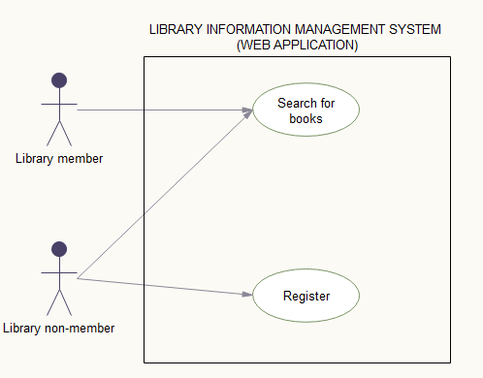

Figure 1: Library Information Management System - Web application use case

(Source: Project Report 2018)

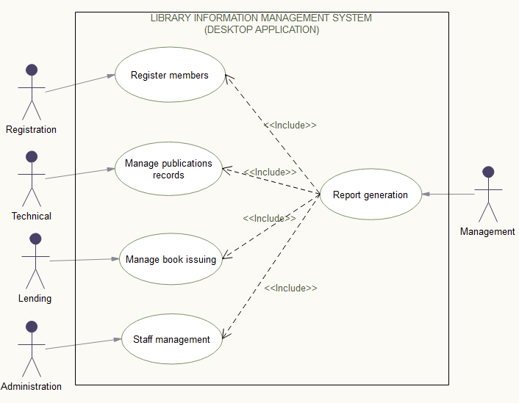

Figure 2: Library information management system - Desktop application use case

(Source: Project Report 2018)

**Class diagram**

This is among the UML diagrams are used when developing an object-oriented system model to show the classes in a system and the associations between these classes. (Sommerville, 2011)

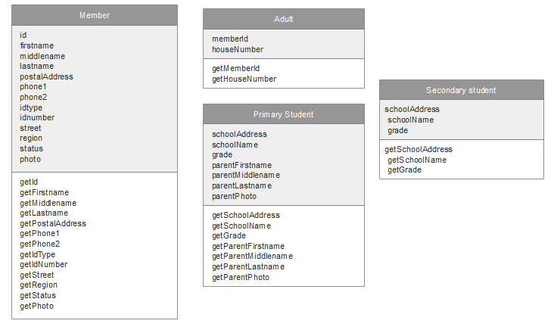

Figure 3: Class diagram of member, adult, primary and secondary student members.

(Source: Project Report 2018)

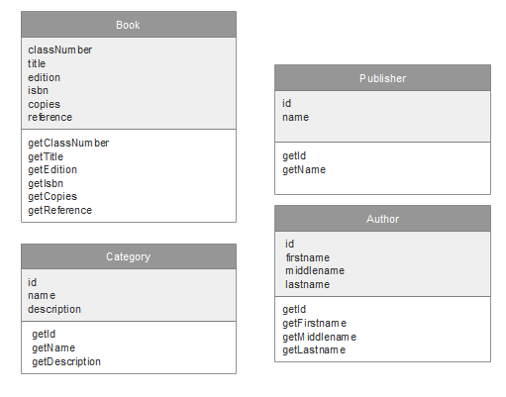

Figure 4: Class diagram of book, category, publisher and author classes

(Source: Project Report 2018)

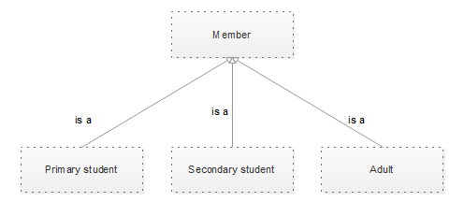

Figure 5 : Class diagram showing inheritance between primary, secondary and adult classes

(Source: Project Report 2018)

## 3.5 System requirements

### 3.5.1 Functional requirements

These are the requirements that identify the function of the systems. They state services the system should provide, how the system should react to particular inputs and how the system should behave in particular situations. (Pressmane, 2009)

* **Online book catalogue:** The web-based application should enable customers to search for specific books by title, or category and see if they exist in the library records.
* **Automate registration process:** The web-based application should enable customers to register so as they can acquire library membership
* **Staff records management**: The system should be able to store and manage records concerning library staff.
* The system should simplify the searching process for a specific record such as specific library member’s information
* **Library publications records management.** The system should manage and store all library publications in a suitable way for easy retrieval and updating.
* **Report generation:** The system should automatically generate reports on library members, issuing list, returning of books list, as well as stored publications list. The reports should be flexible. That is filters such as displaying books according to category, publishers or date when they were registered.
* **Manage book issuing records:** The system should be able to keep records of all book issues and returns.

### 3.5.2 Non-functional requirements

These are requirements that define the required reliability and availability of the system.

* **User friendliness**: The system shall have a simple and straightforward interface that will enable users without much technical knowledge to use. The system shall use Swahili language which is the mother tongue of most staff.
* **Security**: The system is to be secured against unauthorized access and data exposure to unauthorized users. Each staff shall have unique credentials (username and password) that will enable them to access the system. The password can be reset only by the administrator in case it is forgotten. All activities performed are logged by the system.
* **Performance (Response time)**: The system shall be able to accommodate large number of users and process number of transactions at highest speed.
* **Maintainability**: In case of errors or change in the business or customer requirements, the system can easily be maintained to adapt to the changing requirements. Available Java documentation and comments available in program source should ensure easy maintenance process.
* **Reliability**: The system administrator has the overall privileges and can perform any task in the system. In case of unavailability of the system by any staff, the administrator can create new user accounts for staff, reset lost passwords and perform any activity in any department

# CHAPTER FOUR: SYSTEM DESIGN

## 4.1 Introduction to system design

System design is the process of defining the components, modules, interfaces, and data for a system to satisfy specified requirements. It is meant to satisfy specific needs and requirement of a business or organization through the engineering of a coherent and well- running system. (Saltzer, 1984) The purpose of system design is to create a technical solution that satisfies the functional requirements for the system.

## 4.2 System development methodology

System development methodology is a framework that is used to structure, plan, and control the process of developing an information system. Existing system development methodology include:- Dynamic Systems Development Model (DSDM), Agile methodologies ( Extreme Programming (XP), Scrum), Joint Application Development (JAD), Lean Development (LD), Rapid Application Development (RAD), Rational Unified Process (RUP), Spiral, Incremental and Waterfall (Traditional)

**Chosen methodology: Incremental development**

With incremental development the system is developed as a series of versions (increments), where each version adds functionality to the previous version. (Sommerville, 2011) First, the requirements are broken down (divided), then implementation is done on each individual requirement and each requirement passes through design, development, testing and implementation phases. Incremental model is also known as V model.

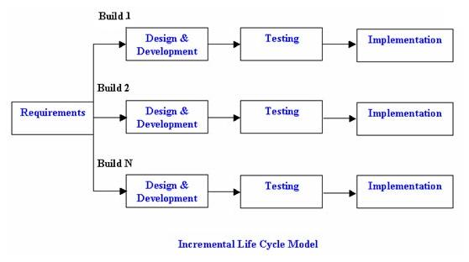

Figure 6 : Incremental Development Methodology

(Source: http:\\www.istqbexamcertification.com)

**Advantages of incremental development**

* Generates working software quickly and early during the software life cycle.
* This model is more flexible – less costly to change scope and requirements.
* It is easier to test and debug during a smaller iteration.
* In this model customer can respond to each built.
* Lowers initial delivery cost.
* Easier to manage risk because risky pieces are identified and handled during it’d iteration.

**Why use incremental development methodology for library information management system?**

* Since this model can be used when the requirements of the complete system are clearly defined and understood. The main requirements for the library information management system were clear during the initial phase of the project.
* Not all requirements details were available during the initial phase of the project. Some of the requirements details evolved as the project progressed. Initially, one of the requirements was to ensure that the system would enable registration process of members automatically and later on it was apparent that some members information would need to be updated when the need arises and thus adding a requirement for staff to update members’ information.
* The system needed to be completed within a short period time and thus incremental methodology was the suitable choice.
* During the development phase, JavaFX framework was employed. This is a fairly new technology thus required each requirement be developed and tested individually to make sure it performs as required before completing the whole project.

## 4.3 Database design

Database design focuses on how the database structure will be used to store and manage end-user data (Coronel, Morris, & Rob, 2009). The database design for the proposed system is as shown below.

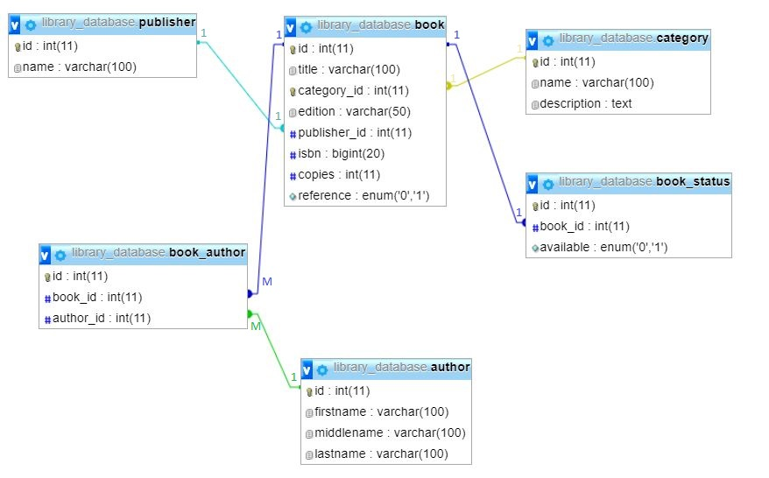

Figure 7 : Entity Relationship Diagram between Book, Publisher, Category and Author

(Source: Project Report 2018)

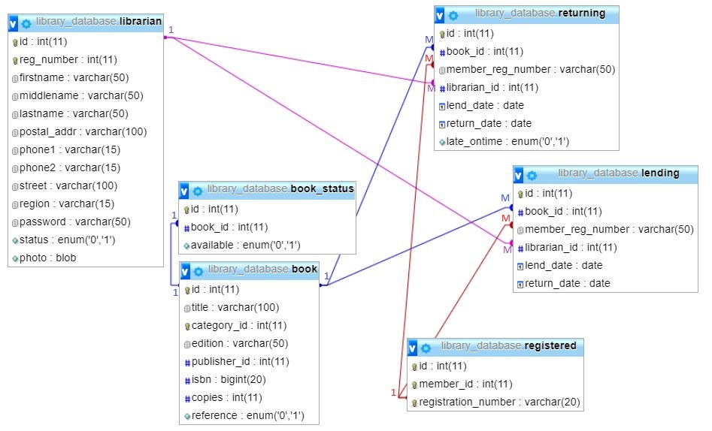

Figure 8 : Entity relationship diagram between librarian, book, lending and returning

(Source: Project Report 2018)

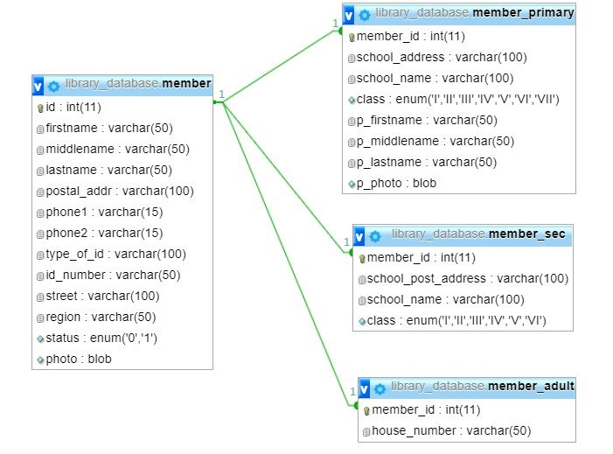

Figure 9 : Entity relationship diagram between member, primary student, secondary student and adult

(Source: Project Report 2018)

## 4.4 User interface design

User interface design (UI) is the design of user interfaces for machines and software, such as computers, home appliances, mobile devices, and other electronic devices, with the focus on maximizing usability and the user experience. (Wikipedia, 2018) The main aim of user interface design is to simplify human interaction with the computer and make it as efficient as possible.

**Sketches of user interface:**

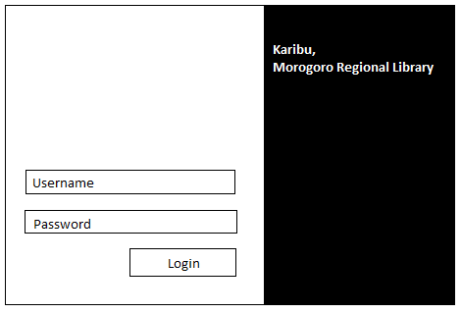

Figure 10: A sketch of a login window (Source: Project Report 2018)

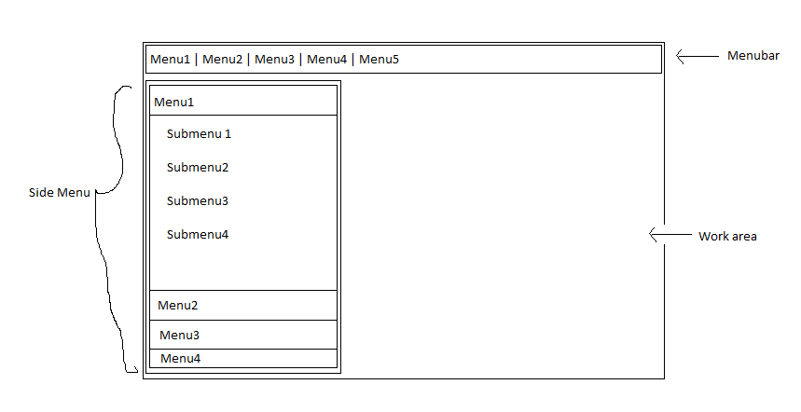

Figure 11: A sketch of main window (Source: Project Report 2018)

# CHAPTER FIVE: SYSTEM IMPLEMENTATION

## 5.1 Introduction

System implementation is the development, installation and testing of system components and delivery of that system components and delivery of that system into production (Jiang, Klein, & Balloun, 1996). Here, we will see how the system design was implemented to achieve the stated functionalities.

## 5.2 Functionalities implementation

The library information management system is made up of a web-application and desktop application.

**Online book catalogue**

Customers can query the library database for specific books by book title and category. The results of the query are also shown in the photo below.

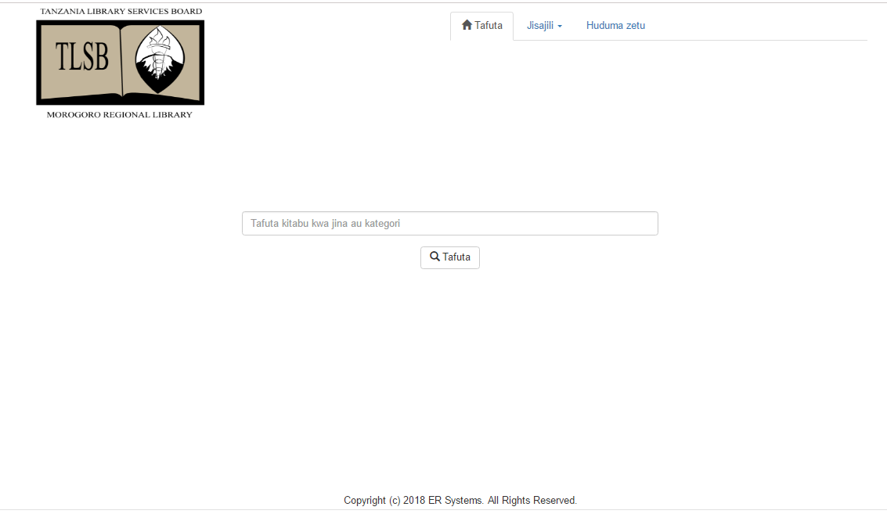

Figure 12: Website home page (Source: Project Report 2018)

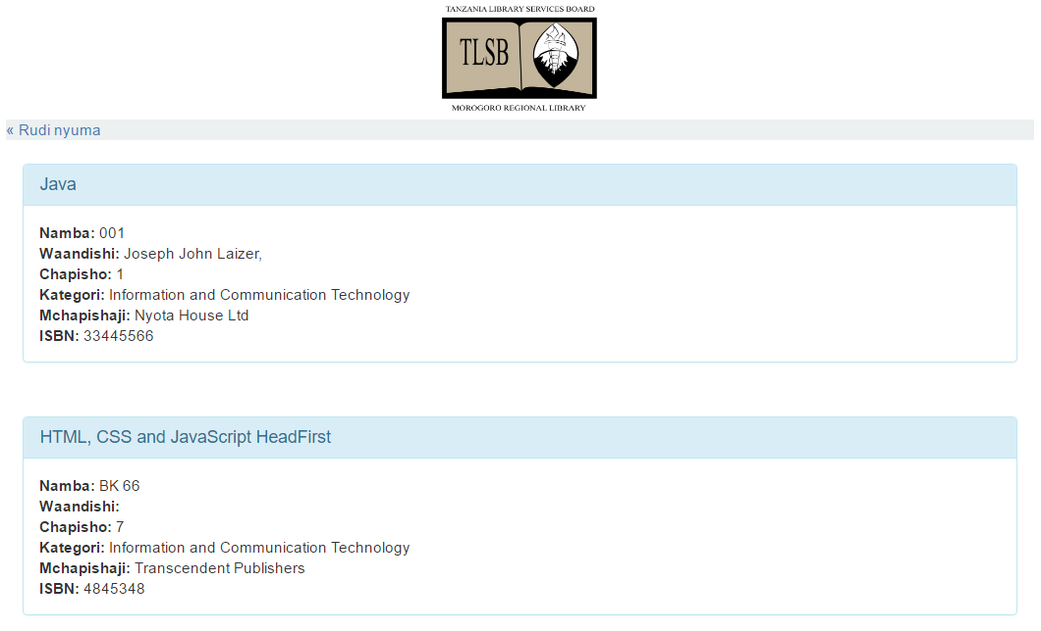

Figure 13: Results of book searching page (Source: Project Report 2018)

**Members’ registration form**

Customers can become library members by registering through the website. They can fill the required information in the form below and submit it.

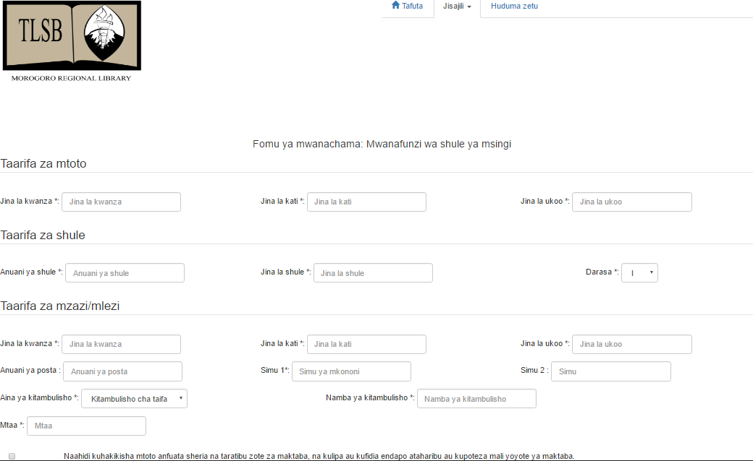

Figure 14: Membership registration form (Source: Project Report 2018)

## 5.3 User Interface Implementation

In the desktop application, when the user opens the program, he/she supplies his/her credentials (username and password) to get access in the system. After login in, a window with respective menu will open depending on the department of the logged in user. Each user will have access to functionalities of his/her own department only. Only the administrator will have access to all the system functionalities.

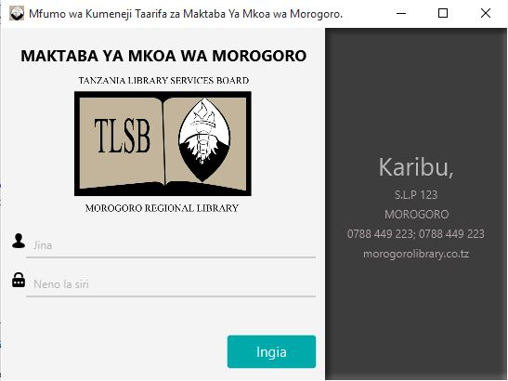

Figure 15: Login window (Source: Project Report 2018)

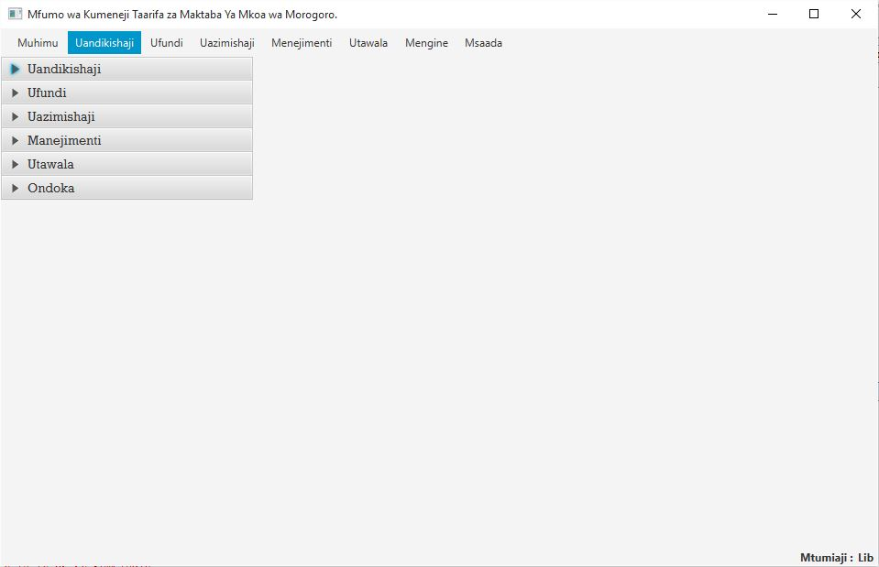

Figure 16: Administrator main window (Source: Project Report 2018)

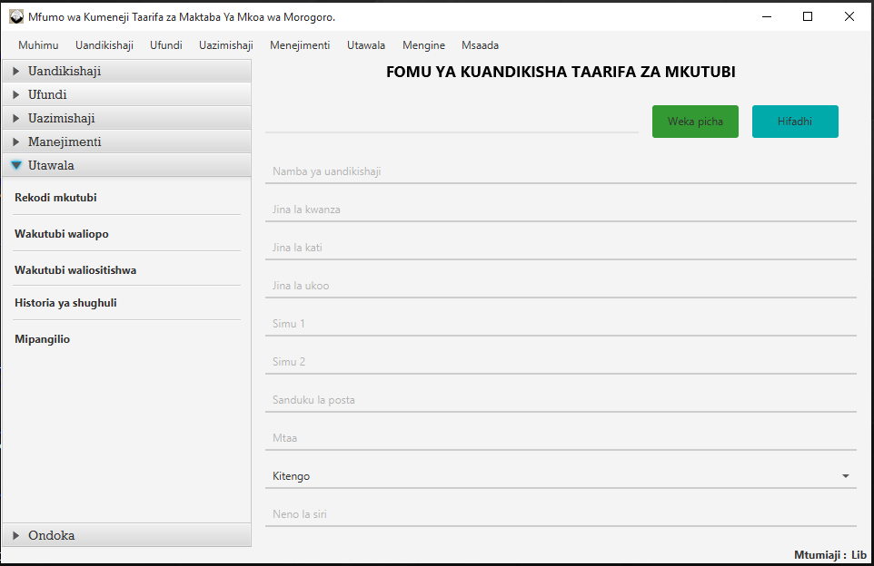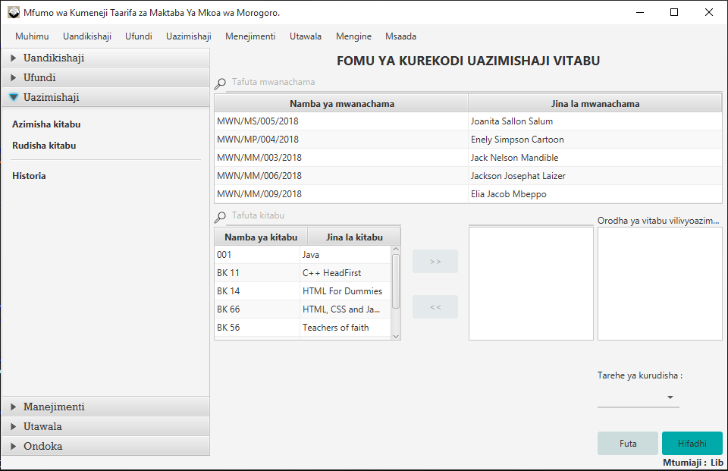

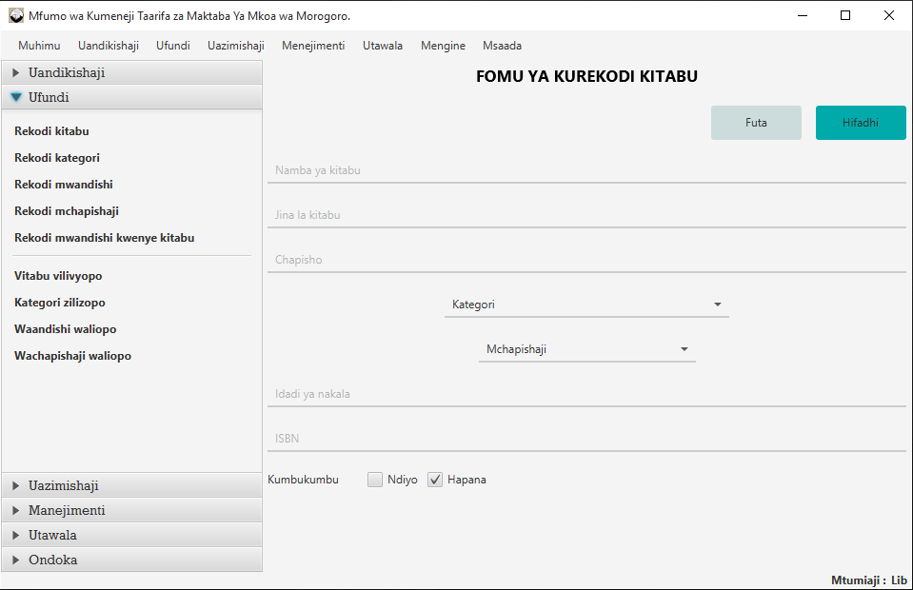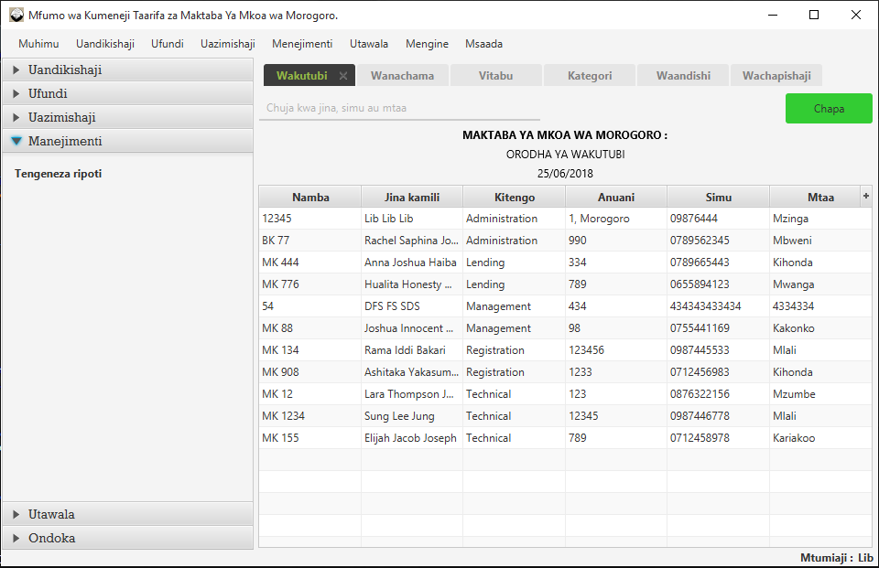

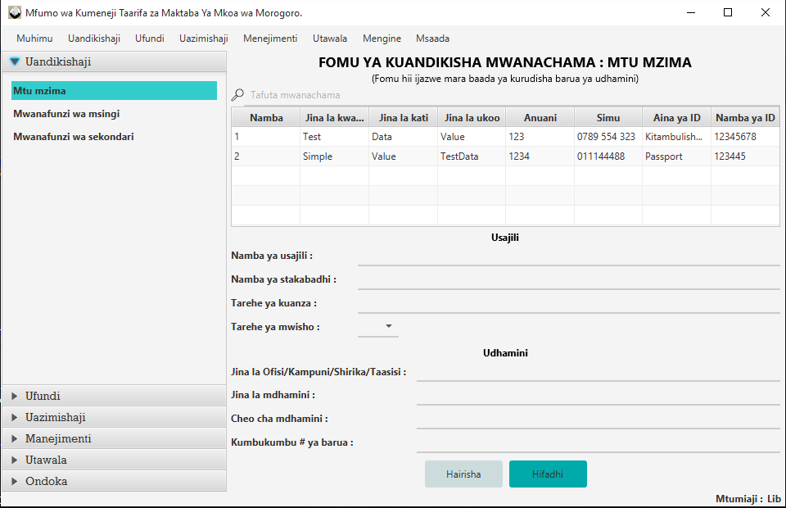

Figure 17: Different windows for different department functionalities

((1) Administration (2) Lending (3) Technical (4) Management (5) Registration)

(Source: Project Report 2018)

## 5.4 Database Implementation

To implement the database that will store the library information 18 tables were created, each table to hold specific information. The following are the tables with the information they stored.

**Book table**

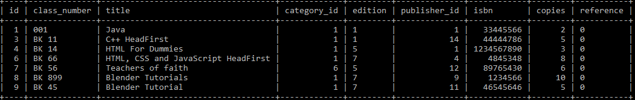

Figure 18: Book table (Source: Project Report 2018)

**Author table**

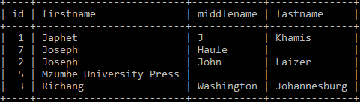

Figure 21: Author table (Source: Project Report 2018)

**Book_Author table**

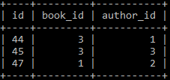

Figure 22: Book_Author table (Source: Project Report 2018)

**Librarian table**

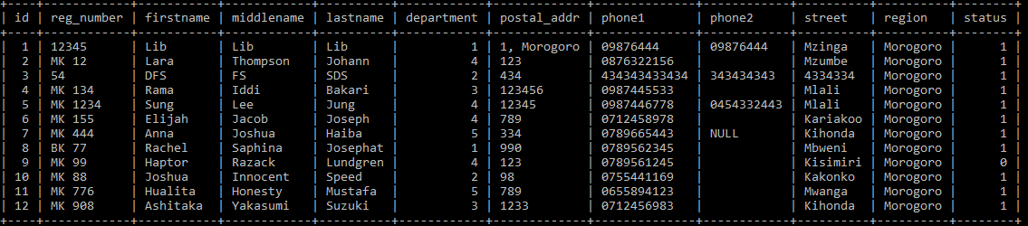

Figure 23: Librarian table (Source: Project Report 2018)

**Member table**

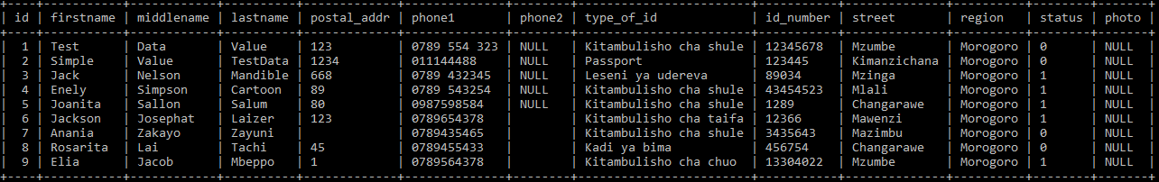

Figure 24: Member table (Source: Project Report 2018)

**Lending table**

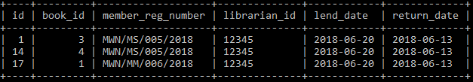

Figure 28: Lending table (Source: Project Report 2018)

**Returning table**

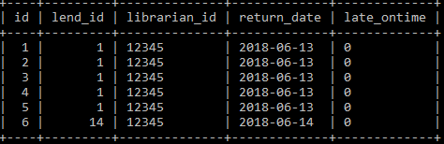

Figure 29: Returning table (Source: Project Report 2018)

## 5.5. System testing and evaluation

System testing of software or hardware is testing conducted on a complete, integrated system to evaluate the system's compliance with its specified requirements. (Wikipedia, 2018) The following are the various types of testing carried out during Library Information Management System testing.

**Unit testing**

Unity testing is testing that test the parameters of the program as independent functional unit. The system had a unit testing where each department unit was tested to see if it functioned individually. Starting with the registration unit, where registered members were shown. On clicking a member, staff can fill in details such as sponsors and receipt number and complete the registration process. The technical unit was tested to see if books can be recorded, and be assigned in specific categories, publisher and authors. In the lending unit, the system was tested to see if issuing and returning of books can be recorded, as well as issuing history be kept by the system. The management unit was tested to see if different reports such as book reports, category reports, staff reports and members’ reports can be generated by the system. And lastly, the administration unit was tested to see if staff information can be recorded, staff can be blocked and unblocked, user passwords can be reset and if logs can be kept by the system.

**Integration testing**

After unit testing of each particular department unit, the system was integrated to form a whole system and tested as a whole for functional requirements.

**Compatibility testing**

This type of testing is intending to check if the system will be compatible with several operating systems version and environment both previous and future. The system was tested in Linux distribution Ubuntu 14.04 with JDK 1.8 installed. The system operated successfully.

**Functional testing**

This is the testing which tests if the functions of the application are working as in the specification and as in documentation. The system had a functional testing to see if it can really user can register as a library member online, also a system can store and manage library information’s and generate report automatically

# CHAPTER SIX: CONCLUSION AND RECOMMENDATION

## 6.1 Summary of achieved objectives

The analysis design and development of library information management system was reckoned successful. This assessment was made based on the functionality of the final system meeting the requirement analysis. The application satisfactorily meets the core requirement set out at the initiation of the project.

Apart from the general achieved objectives of library information management system that is application being run able and being able to do by 90% of the function other specific objectives of the application are as follows

Several library information management systems successful made possible to manage and keep records of all library information’s. The system should automatically generate reports on library members, issuing list, returning of books list, as well as stored publications list. The reports should be flexible. That is filters such as displaying books according to category, publishers or date when they were registered User can both encrypt and decrypt their message either way.

Library information management system can run on any operating system. One of the reasons to develop Library Information Management System (LIMS) using java was to enable it to be able to run in many devices with different hardware specification and software requirements. Library Information Management System (LIMS) build is successfully in platform independent it can run in most operating systems such as windows OS, Linux, Mac OS hence the application can reach a huge number of users.

## 6.2 Conclusion

In this project, an online (web based) application and a desktop based was developed. The system has capability to automate Morogoro library membership registration process and manage library record as well as generating management report.

I have developed and implemented the Library Information Management (LIMS) using java as main technology, Java has several advantages to be used in with this project due to two following reasons. One java runs in many devices and hence the application will be able to reach a huge number of users. Two java has well implementation and libraries to be used with security features hence make it the number one choice for this application. To build a desktop application we must make it easy to use with a lot of human interactive features and hence I have used javafx which provided the good GUI for the application and controls but also I have used CSS which take part in the styling of the whole application making it user friendly, easy to navigate, safe to use, very effective, easy to use, reduce user frustration from using a computer and having a good appeal to the users.

Library Information Management (LIMS) project helps in understanding the creation of desktop application using java, javafx and CSS technologies. The design of the project includes backend, frontend and shows flow of the data in the application. The building of this project has given me an enormous knowledge about how to develop and implement desktop application using java and javafx technologies how to connect the javafx and customize it using CSS and how to code which is termed good programming and the principle of achieving a good programming behavior.

## 6.3 Recommendations and future works

Through the overall project was a success, there are certain area that could be enhance even further or modified way more according to user requirements. The proposed system is LIMS, This system is recommended for implementation and use by all people as it can greatly help to manage and store library information’s that is involved in the manual ways of library information’s.

# REFERENCE

Pressman, R. S. (2009). Software Engineering A Practitioner’s Approach 7th Ed - Roger S. Pressman. http://doi.org/10.1017/CBO9781107415324.004

Schildt Herbert. (2014). *Java: A Beginner’s, Guide create, compile and run Java today.* *6th edition. New York USA, Oracle Press.*

*What is System Design? - Definition from Techopedia*. (2018). *Techopedia.com*. Retrieved21 May 2018, from https://www.techopedia.com/definition/29998/system-design

Clark, D. D., & Wilson, D. R. (1987, April). A comparison of commercial and military computer security policies. In *Security and Privacy, 1987 IEEE Symposium on* (pp. 184-184). IEEE.

Kim TopLey. (2011). *JavaFx Developer’s guide. 1st Edition Pearson Education Inc. Michigan USA.*

Ahituv, N., Neumann, S., & Zviran, M. (2002). A system development methodology for ERP systems. *Journal of Computer Information Systems*, *42*(3), 56-67.

Kerzner, H. (2013). *Project management: a systems approach to planning, scheduling, and* *controlling*. John Wiley & Sons.

Darwin’s F.  Ian. (2004). *Java Cookbook: Solutions and Examples for Java Developers*. *USA O’Reilly Media Inc.*

Kim, H., Kang, S., Baik, J., & Ko, I. (2007, July). Test cases generation from UML activity diagrams. In *Software Engineering, Artificial Intelligence, Networking, and* *Parallel/Distributed Computing, 2007. SNPD 2007. Eighth ACIS International Conference on* (Vol. 3, pp. 556-561). IEEE.

Porter, A. A., Votta, L. G., & Basili, V. R. (1995). Comparing detection methods for software requirements inspections: A replicated experiment. *IEEE Transactions on* *software Engineering*, *21*(6), 563-575.

Pomarolli A. (2016). *JavaFx Programming CookBook: Hot Recipes for JavaFx development. Exelixis Media P.C.*

*System Design and Development*. (2017). *The MITRE Corporation*. Retrieved 21 May2018, from https://www.mitre.org/publications/systems-engineering-guide/se-lifecycle-building-blocks/system-design-and-development

Umber, A., Naweed, M. S., Bashir, T., & Bajwa, I. S. (2012). Requirements Elicitation Methods. In *Advanced Materials Research* (Vol. 433, pp. 6000-6006). Trans Tech Publications.

Booch, G., Rumbaugh, J., & Jacobson, I. (2005). *The Unified Modeling Language User* https://www.capterra.com/contact-management-software/

*Guide*. *Addison-Wesley Object Technology Series* . Coronel, C., Morris, S., & Rob, P. (2009). *Database Systems: Design, Implementation, and* *Management*.

*Management*. Credé, A., & Mansell, R. (1998). *Knowledge Societies in a Nutshell: Information* *Technology for Sustainable Development*.